International Premier Bank would like to build a Sales-Marketing system to help sales agents decide if they should contact a customer to purchase a CD (certificate of deposit).

A data set has been provided. Check the Github repository.

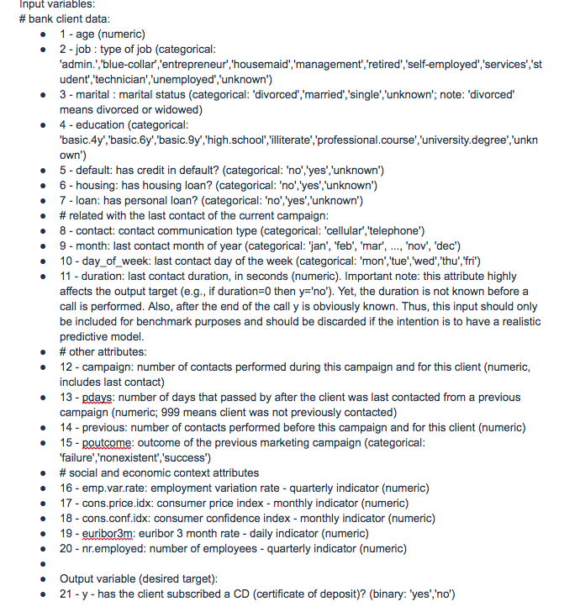

Assignment:

1. Use Jupyter Notebook for the analysis below
2. Provide an analysis on what features are more likely to get a customer to buy a CD
3. Build several predictive classifiers using different types of machine learning models/algorithms
4. Compare and contrast classifiers using cross validation
5. Anything else interesting you discovered and would like to share